# ASSIGNMENT-3 TIME SERIES DATA

-Vineeth Rudraksha

# Introduction: -

The time-series forecasting technique is one of the core units in several domains e.g. financial, weather prediction, and trade analysis. RNNs (recurrent neural networks) proved to be adept at time-series data and even better in capturing temporal dependencies due to their characteristic which is the capability to consider time-points of phenomenon. It tests a recurrent neural network model against weather time-series data to see how it performs, and, then, it compares various approaches to enhance the model’s accuracy.

# Methodology: -

We have toyed around with several RNN topologies, modifying the numbers of units in each recurrent layer, using layer_lstm instead of the layer_gru, in addition to incorporating a 1D convNet and RNN. Historical weather data sets with max, min, and average temperature, humidity, wind direction and rate, precipitation, and other parameters are used for the research.

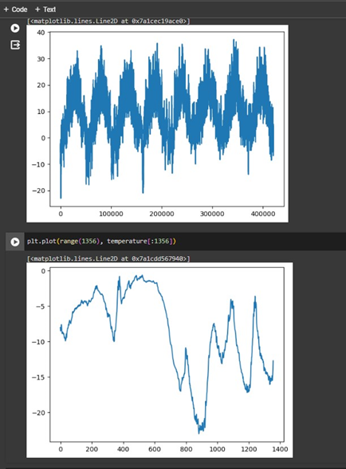

**Changing the Recurrent Layers**:

**Utilizing Various Types of Recurrent Layers**:

Before going further with the input of the time-series data into the LSTM experimental it is essential to define the input shape in addition to normalizing the input features. Our model architecture begins at the input layer that takes the designated shape as its input and a unit of 16 within the LSTM layer. Right after there is a single neuron with a dense layer comes out the output prediction. The compilation as well as the training select a suitable optimizer (for example Adam) and loss function (for instance Mean Squared Error), together with training parameters such as the batch size, epoch count and validation split. Metrics like MAE are applied in order to test the model following which performance can be improved by tweaking the values or hyperparameter tuning. Training the model, its behavior can be pictured through the interpretation and visualization of these curves to be used for the summarizing of the training and validation loss curves. Ultimately, evaluation on an independent test set will be the final criteria for an objective performance of the model.

# Combining 1D Convolutional Neural Networks (CNNs) and RNNs: -

By combining the convolutional layer of 1D with RNNs, time-series data modeling can be enhanced by taking advantage of both architecture's merits. This mechanism helps in detecting the key temporal patterns and trends by applying the 1D convolutional layers to extract local patterns and spatial features from the input time-series sequences. Through the process of down sampling the input sequences, they reduce the computational burden and extract features at different temporal scales. The feed-forward layers, such as LSTM or GRU that can extract long-range and temporal dependencies of the data, take the output of the convolutional layers as their input. The model is competent in addressing spatial and temporal as well as sequence predicting and classifying.

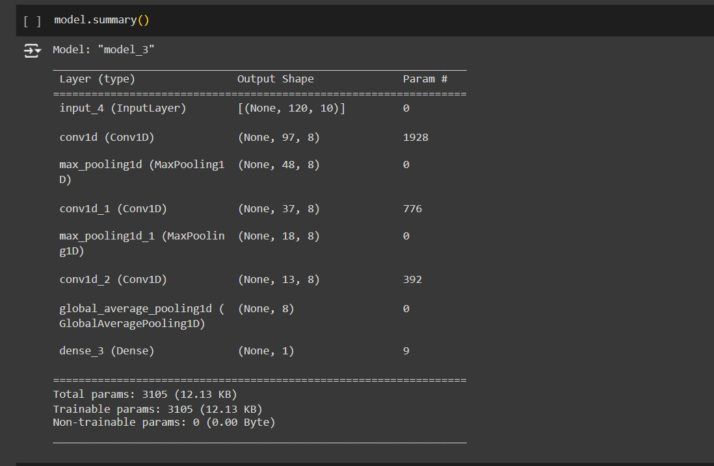

# Results: -

**Using Different Recurrent Layer Types:**

Identifying the recurrent layer types in a neural network denotes the choice among different architectures such as GRU (Gating Recurrent unit) and LSTM (Long Short-Term Memory). Armed with the ability to process temporal connections in sequential data, these multiple types of recurrent layers are designed. The long-range dependencies and vanishing Gradient problem are very well conquered since LSTM cells can preserve long-term memory and regulate the passage of information through gates by their vast capacities. Nevertheless, the GRU units require quicker learning speeds or better performance when using scenarios with a limited amount of data or computational resource since they are straightforward and fewer in the number of components. The situation regarding the adoption of LSTM or GRU layers depends on such factors as size of dataset, computational constraints, data complexity, and others. This flexibility increases the possibility of building a lot of different ultra-efficient recurrent neural networks that have the required framework for specific purposes such as goal achievement and tasks completion.

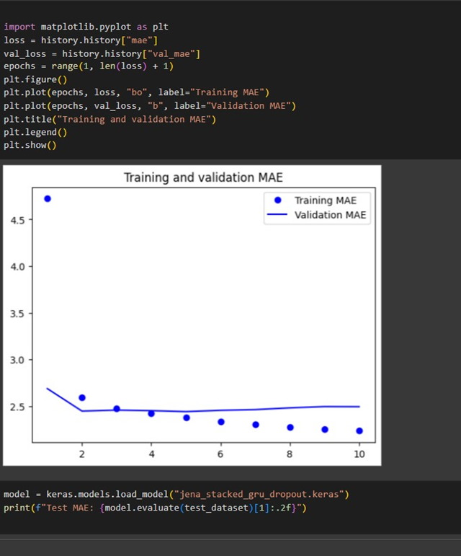

**Combining 1D CNNs with RNNs**:

To carry out the efficient modeling of time-series data 1D Convolutional Neural Networks (CNNs) and Recurrent Neural Networks (RNNs) combined the characteristics that are best in both architectures. Through local pattern and feature extraction by way of one-dimensional CNNs from sequential input data in this strategy the network is to detect important temporal patterns at different scales and analyze spatial inter-dependencies. The subsequent convolutional layers' produced feature map is applied to the recurrent layers like LSTM or GRUs to uncover the time and long range dependencies from the data. This assembly allows the model to process the input sequences using CNNs' capability of identifying features and RNNs' ability to disclose sequential dependency which raise the competence of the model in applications including anomaly detection, sequence classification, and time-series forecasting.

|  |  |  |  |  |
| --- | --- | --- | --- | --- |
| S No | Method | Training_mae | Val_mae | Test_mae |
| 1 | recurrent layer of 16 | 0.2551 | 0.2484 | 0.33 |
| 2 | recurrent layer of 16 | 0.2551 | 0.2484 | 0.25 |
| 3 | LSTM | 0.2569 | 0.2475 | 0.25 |
| 4 | Combining 1D CNNs with RNN | 0.2509 | 0.2482 | 0.2468 |

Conclusion: -

RNNs can bring up a reliable base for time series forecasting, especially in meteorological predictions. Especially by going through different configurations and methods with the use of hybrid architectures and layered layers, then the forecasting process can be endowed with greater accuracy. More complex strategies, such as ensemble methods and attention mechanisms, could be further analyzed to achieve more accurate forecasting of weather.